MODULO MACRIJA

Habrá dos tipos de importación: la del fichero de **diario** (que es el de la recaudación física de las máquinas de los locales) y la de importación del fichero **mensual** (que es la contabilización de las facturas de comisiones a los locales por los importes recaudados ese mes).

**DIARIO**

El fichero de diario genera 4 apuntes. Por una parte, se ingresa por caja, la 570 (contra la 4008) el total de la recaudación y por otra parte se imputa a la 4008 (contra caja) lo que se le da al bar. En el caso de que un local tenga 2 o más máquinas, se suman las líneas.

Ejemplo:

"01/08/2024","01","0502","DOLCE VITA-BAR","B1194","MANHATTAN PARTY","24","586","B","190.00","0.00","0.00","57.00","133.00","0","FABREGAT MARTINEZ, SIRA","20.467.009-E","400000292","Yes","C/ Pere de Thous, 1 izq. 3º.C","BENICARLÓ","CASTELLÓ DE LA PLANA","12580"

"01/08/2024","01","0502","DOLCE VITA-BAR","F0265","EXP. GRUA HAPPY PARK","HHC","66","A","18.00","0.00","0.00","3.00","15.00","0","FABREGAT MARTINEZ, SIRA","20.467.009-E","400000292","Yes","C/ Pere de Thous, 1 izq. 3º.C","BENICARLÓ","CASTELLÓ DE LA PLANA","12580"

En este ejemplo, el bruto serían 190+18 y lo abonado al local serían 57+3

El asiento quedaría:

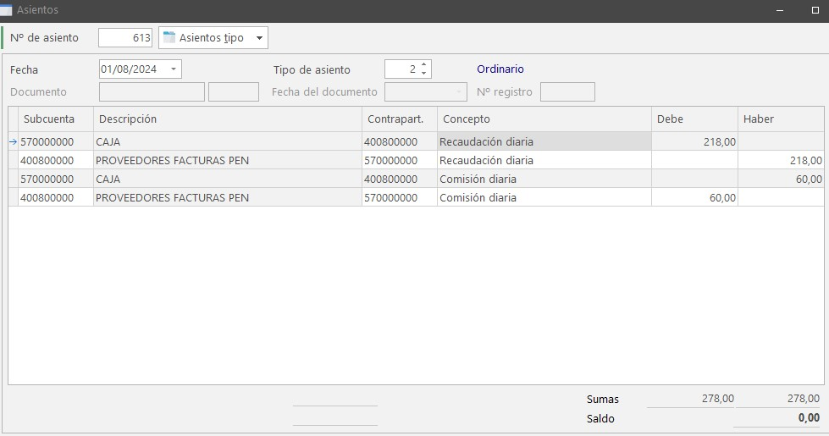

570 218.00d

4008 218.00h

570 60h

4008 60d

**MENSUAL**

En cada cliente la factura de venta va contra la misma cuenta SIEMPRE (la 4008), y en la factura al cliente (que en realidad es la máquina de cada establecimiento) se desglosa por tipo de maquina y solo hay una línea de IVA:

Ejemplo:

"31/07/2024","01/24/580","PPSSL/24/5","01","0439","PE ISCOLA PLAZA-CAFETERIA","A","1760.00","1454.55","21.00","305.45","601.04","21.00","126.22","727.26","0","ZT HOTELS & RESORTS, S.L.","B-12.019.485","400000439","Yes","A","PPSSL","430000439"

"31/07/2024","01/24/580","PPSSL/24/5","01","0439","PE ISCOLA PLAZA-CAFETERIA","B","1980.00","1980.00","0.00","0.00","495.87","21.00","104.13","600.00","0","ZT HOTELS & RESORTS, S.L.","B-12.019.485","400000439","Yes","B","PPSSL","430000439"

"31/07/2024","01/24/580","PPSSL/24/5","01","0439","PE ISCOLA PLAZA-CAFETERIA","A","2870.00","2371.88","21.00","498.12","979.98","21.00","205.80","1185.78","0","ZT HOTELS & RESORTS, S.L.","B-12.019.485","400000439","Yes","D","PPSSL","430000439"

"31/07/2024","01/24/580","PPSSL/24/5","01","0439","PE ISCOLA PLAZA-CAFETERIA","A","1820.00","1504.14","21.00","315.86","271.08","21.00","56.92","328.00","0","ZT HOTELS & RESORTS, S.L.","B-12.019.485","400000439","Yes","E","PPSSL","430000439"

"31/07/2024","01/24/580","PPSSL/24/5","01","0439","PE ISCOLA PLAZA-CAFETERIA","A","1360.00","1123.96","21.00","236.04","464.43","21.00","97.53","561.96","0","ZT HOTELS & RESORTS, S.L.","B-12.019.485","400000439","Yes","I","PPSSL","430000439"

EL asiento de la factura de venta quedaría:

4008 9790,00d

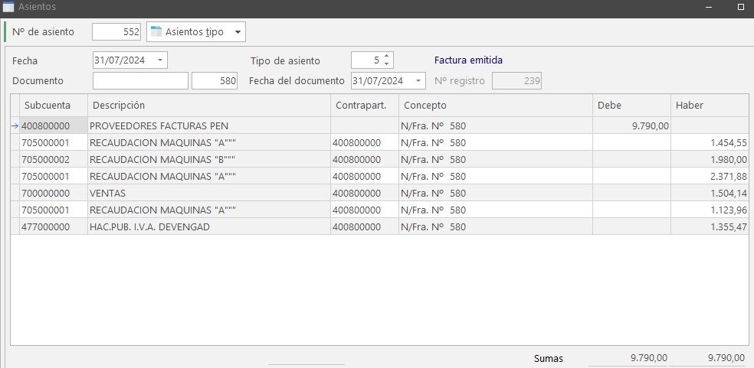

705.1 1454.55h

705.1 2371,88h

705.1 1123.96h

700 1504.14h

705.2 1980,00h (línea sin IVA)

477 1355.47h

La factura recibida de cada proveedor es la comisión que se queda el local, y se desglosa base e IVA, resumiéndose por local. Posteriormente, con el pago, se cancela la 4008.

Siguiendo con el mismo ejemplo:

"31/07/2024","01/24/580","PPSSL/24/5","01","0439","PE ISCOLA PLAZA-CAFETERIA","A","1760.00","1454.55","21.00","305.45","601.04","21.00","126.22","727.26","0","ZT HOTELS & RESORTS, S.L.","B-12.019.485","400000439","Yes","A","PPSSL","430000439"

"31/07/2024","01/24/580","PPSSL/24/5","01","0439","PE ISCOLA PLAZA-CAFETERIA","B","1980.00","1980.00","0.00","0.00","495.87","21.00","104.13","600.00","0","ZT HOTELS & RESORTS, S.L.","B-12.019.485","400000439","Yes","B","PPSSL","430000439"

"31/07/2024","01/24/580","PPSSL/24/5","01","0439","PE ISCOLA PLAZA-CAFETERIA","A","2870.00","2371.88","21.00","498.12","979.98","21.00","205.80","1185.78","0","ZT HOTELS & RESORTS, S.L.","B-12.019.485","400000439","Yes","D","PPSSL","430000439"

"31/07/2024","01/24/580","PPSSL/24/5","01","0439","PE ISCOLA PLAZA-CAFETERIA","A","1820.00","1504.14","21.00","315.86","271.08","21.00","56.92","328.00","0","ZT HOTELS & RESORTS, S.L.","B-12.019.485","400000439","Yes","E","PPSSL","430000439"

"31/07/2024","01/24/580","PPSSL/24/5","01","0439","PE ISCOLA PLAZA-CAFETERIA","A","1360.00","1123.96","21.00","236.04","464.43","21.00","97.53","561.96","0","ZT HOTELS & RESORTS, S.L.","B-12.019.485","400000439","Yes","I","PPSSL","430000439"

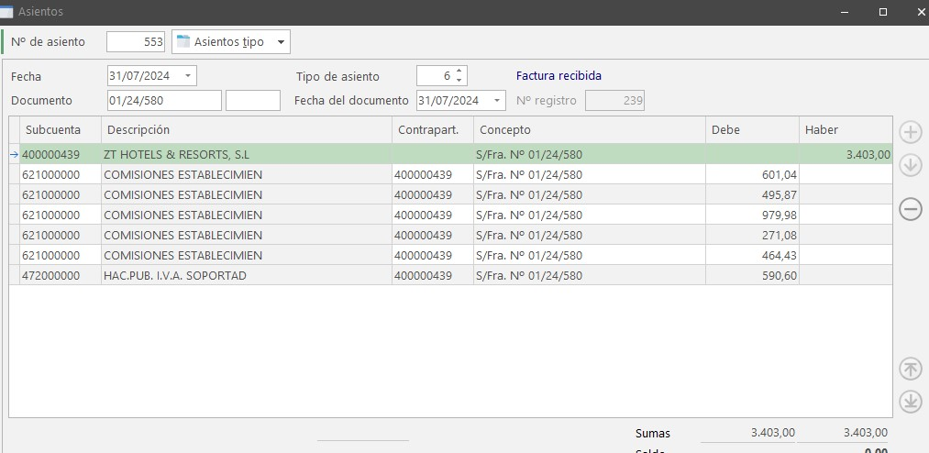

La factura recibida sería:

400000439 3403,00H

621000000 2812,40d

472000000 590,60d

El pago:

400000046 3403,00d

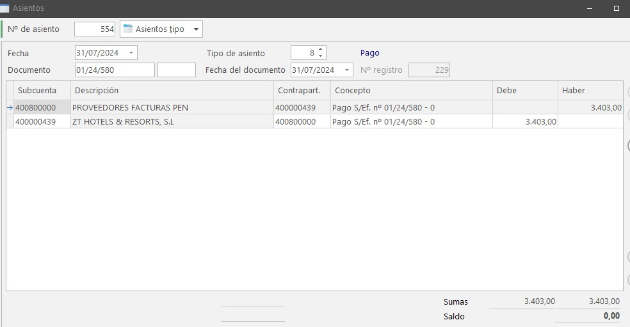

400800000 3403,00h